

|  |
| --- |
|  |
| Healthcare Accelerator V2.2.3.X  Release Documentation |
| July 23  Microsoft  Authored by: Edgar H. Wilson II |

Healthcare Accelerator V2.2.3.X

|  |
| --- |
| Release Updates This document serves as a baseline for what is updated in the Healthcare Accelerator V2.2.3.X – Relaunch. A chief update of the Healthcare Accelerator V2.2.3.X will be the updated look and feel of the model-driven app included with the accelerator with updated controls, icons and updated forms. All existing issues will also be updated as a part of this release including stripping out all dependencies on Dynamics 365 apps. The Healthcare Accelerator will now be able to be installed on a base CDM and will no longer have any pre-requisites for embedded Dynamics 365 applications. |
| *“Provide innovative Healthcare industry solutions to drive prioritized industry ISVs and customers to streamline their time to value with the Power Platform: streamline their time to value with the Power Platform”* |
| The above statement is our strategy statement for the Healthcare Accelerator and we will abide by this principal in every aspect we fold into the solution.  Icon Updates  The previous Healthcare Accelerator model-driven app contains Icons that are very blurry and don’t fit the color scheme of Dynamics. We have performed a complete overhaul on all of the icons exposed in the form and sitemap to provide a fresher look and feel. Below is an example of how the sitemap and form currently look.  **Previous Sitemap Updated Sitemap** |

As can be seen the icons need an overhaul. There was also need to be an update of the icons that are included in the reference panel for the Patient/Physician 360 forms (Shown below):

Previous Reference Pane Current Reference Pane

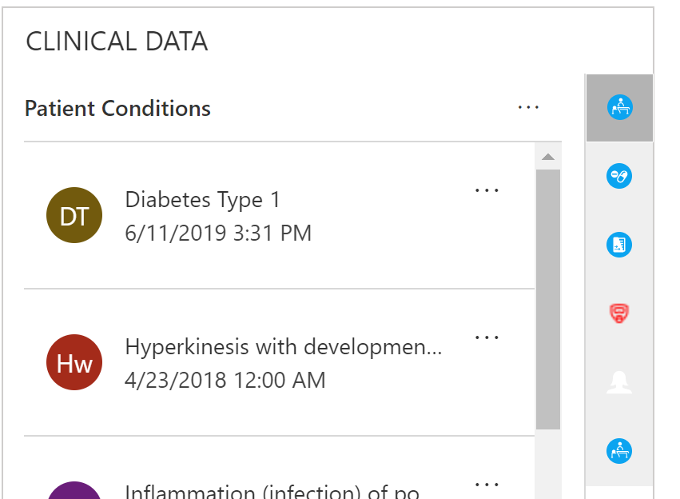 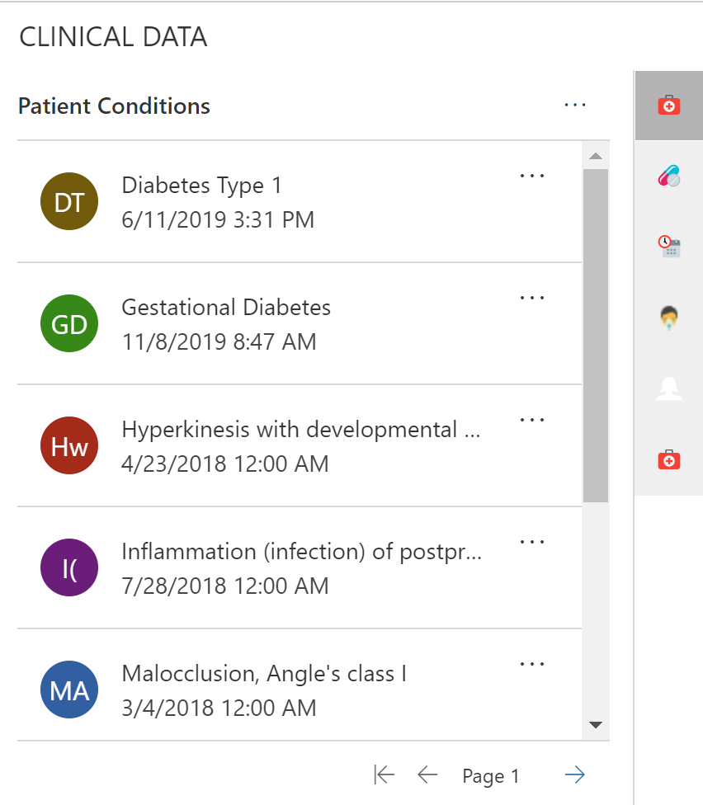

These icons are .svg files for Dynamics Health 365 model-driven app sitemap and .png (16, 32) for forms and legacy sitemap based on the location within the model-driven app.

Control Updates

The embedded Timeline and Care Team viewer controls that shipped with the Healthcare Accelerator Dynamics Health 365 Model-Driven app, has been a major success in closing the gap between our solution and Salesforce. However, the lack of configurability and mundane interface leaves more to be desired from the perspective of our customers. In the December release, our customers need a complete overhaul of these controls to a much more appealing and configurable user interface. Below are the two controls that are currently within the solution today.

Previous Timeline Control

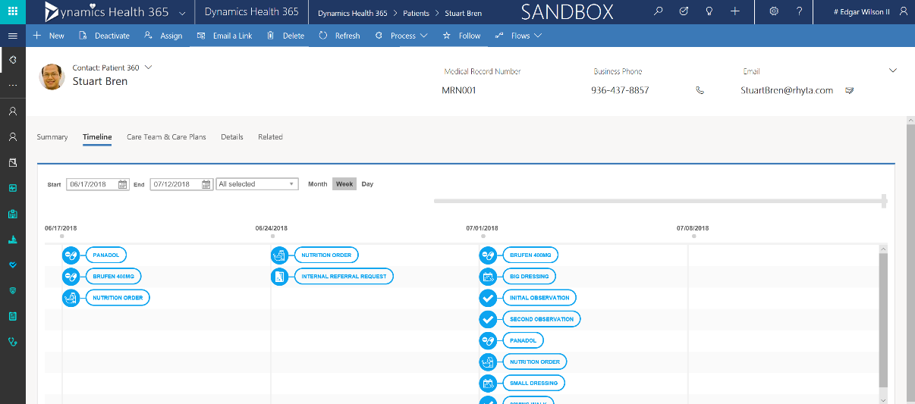

Previous Care Team Control

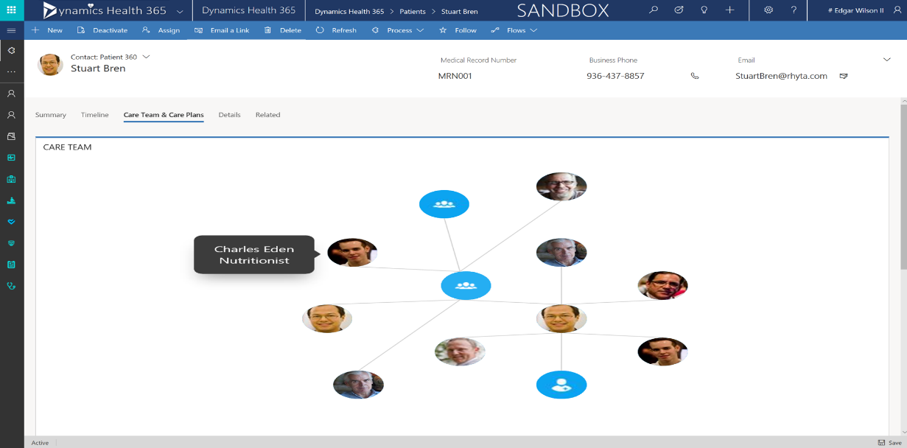

As can be seen the very simple interface can certainly stand for some improvement.

Timeline Control

First, we’ll start with the timeline viewer. The viewer is specifically designed to show EHR data in a sequential fashion. The timeline control also allows the user to choose the dates for wish they would like to see, as well as leverage the slider to find a particular date. The interface and experience of the timeline viewer is less than ideal to say the least. Below is a bulleted list of the updates that were made to the timeline control:

* Updated Icons that correspond to the icon updates above
* Ability to click and view a ‘quick view’ within the timeline that shows the events that are occurring
* Add Care Plans and Care Plan Goals to the timeline
* Sliders that provide the ability to scale dates at the bottom to dictate exact dates on timeline

Below is a screenshot of the updated Timeline

Updated Timeline

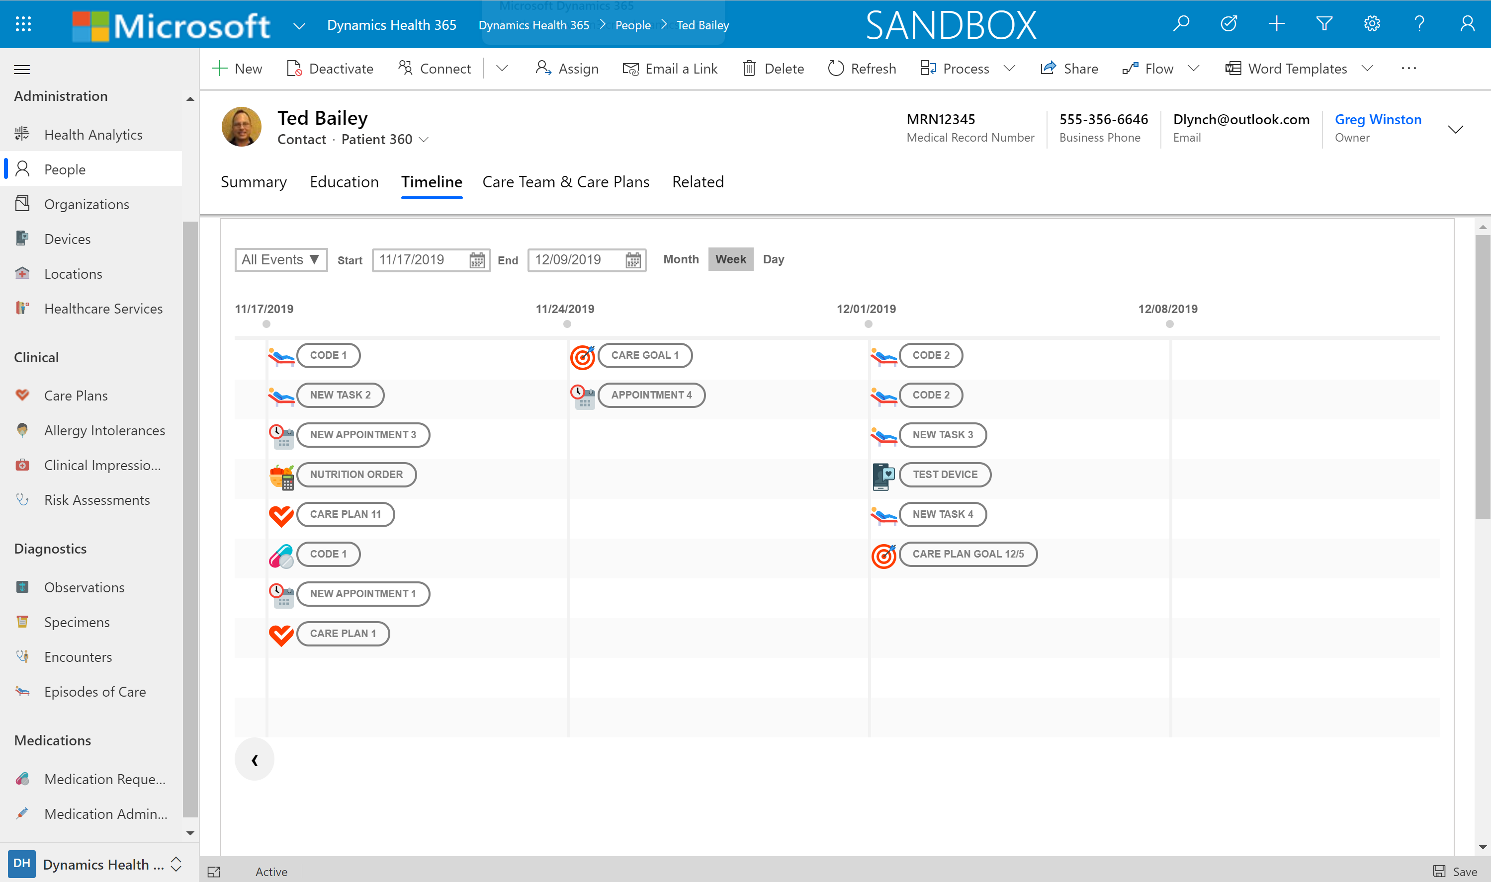

Care Team Control

The Care Team control has actually proved extremely useful for customers who are leveraging the control. Alongside the extension that leverages Flow to associate Care Teams and its member to a corresponding Microsoft team for the patient has made this a very powerful tool. However, historically the control is not the most aesthetically pleasing, nor does it provide a lot of functionality that would really make it even more powerful. Below is a bulleted list of functionality that has been added to the Care Team Control:

* Updated Look and feel of control to improve scaling
* The ability to email or call the care team member through the control
* Smoother branching logic
* Name and Care Team Role of Care Participant Appear without having to hover over the member
* Leverage existing [Teams Integration extension](https://github.com/microsoft/Industry-Accelerator-Health/tree/master/apps/samplecode/healthcare/office/Teams) to provide the ability to send messages to patient care team members and also show teams status in control

Updated Care Team Viewer

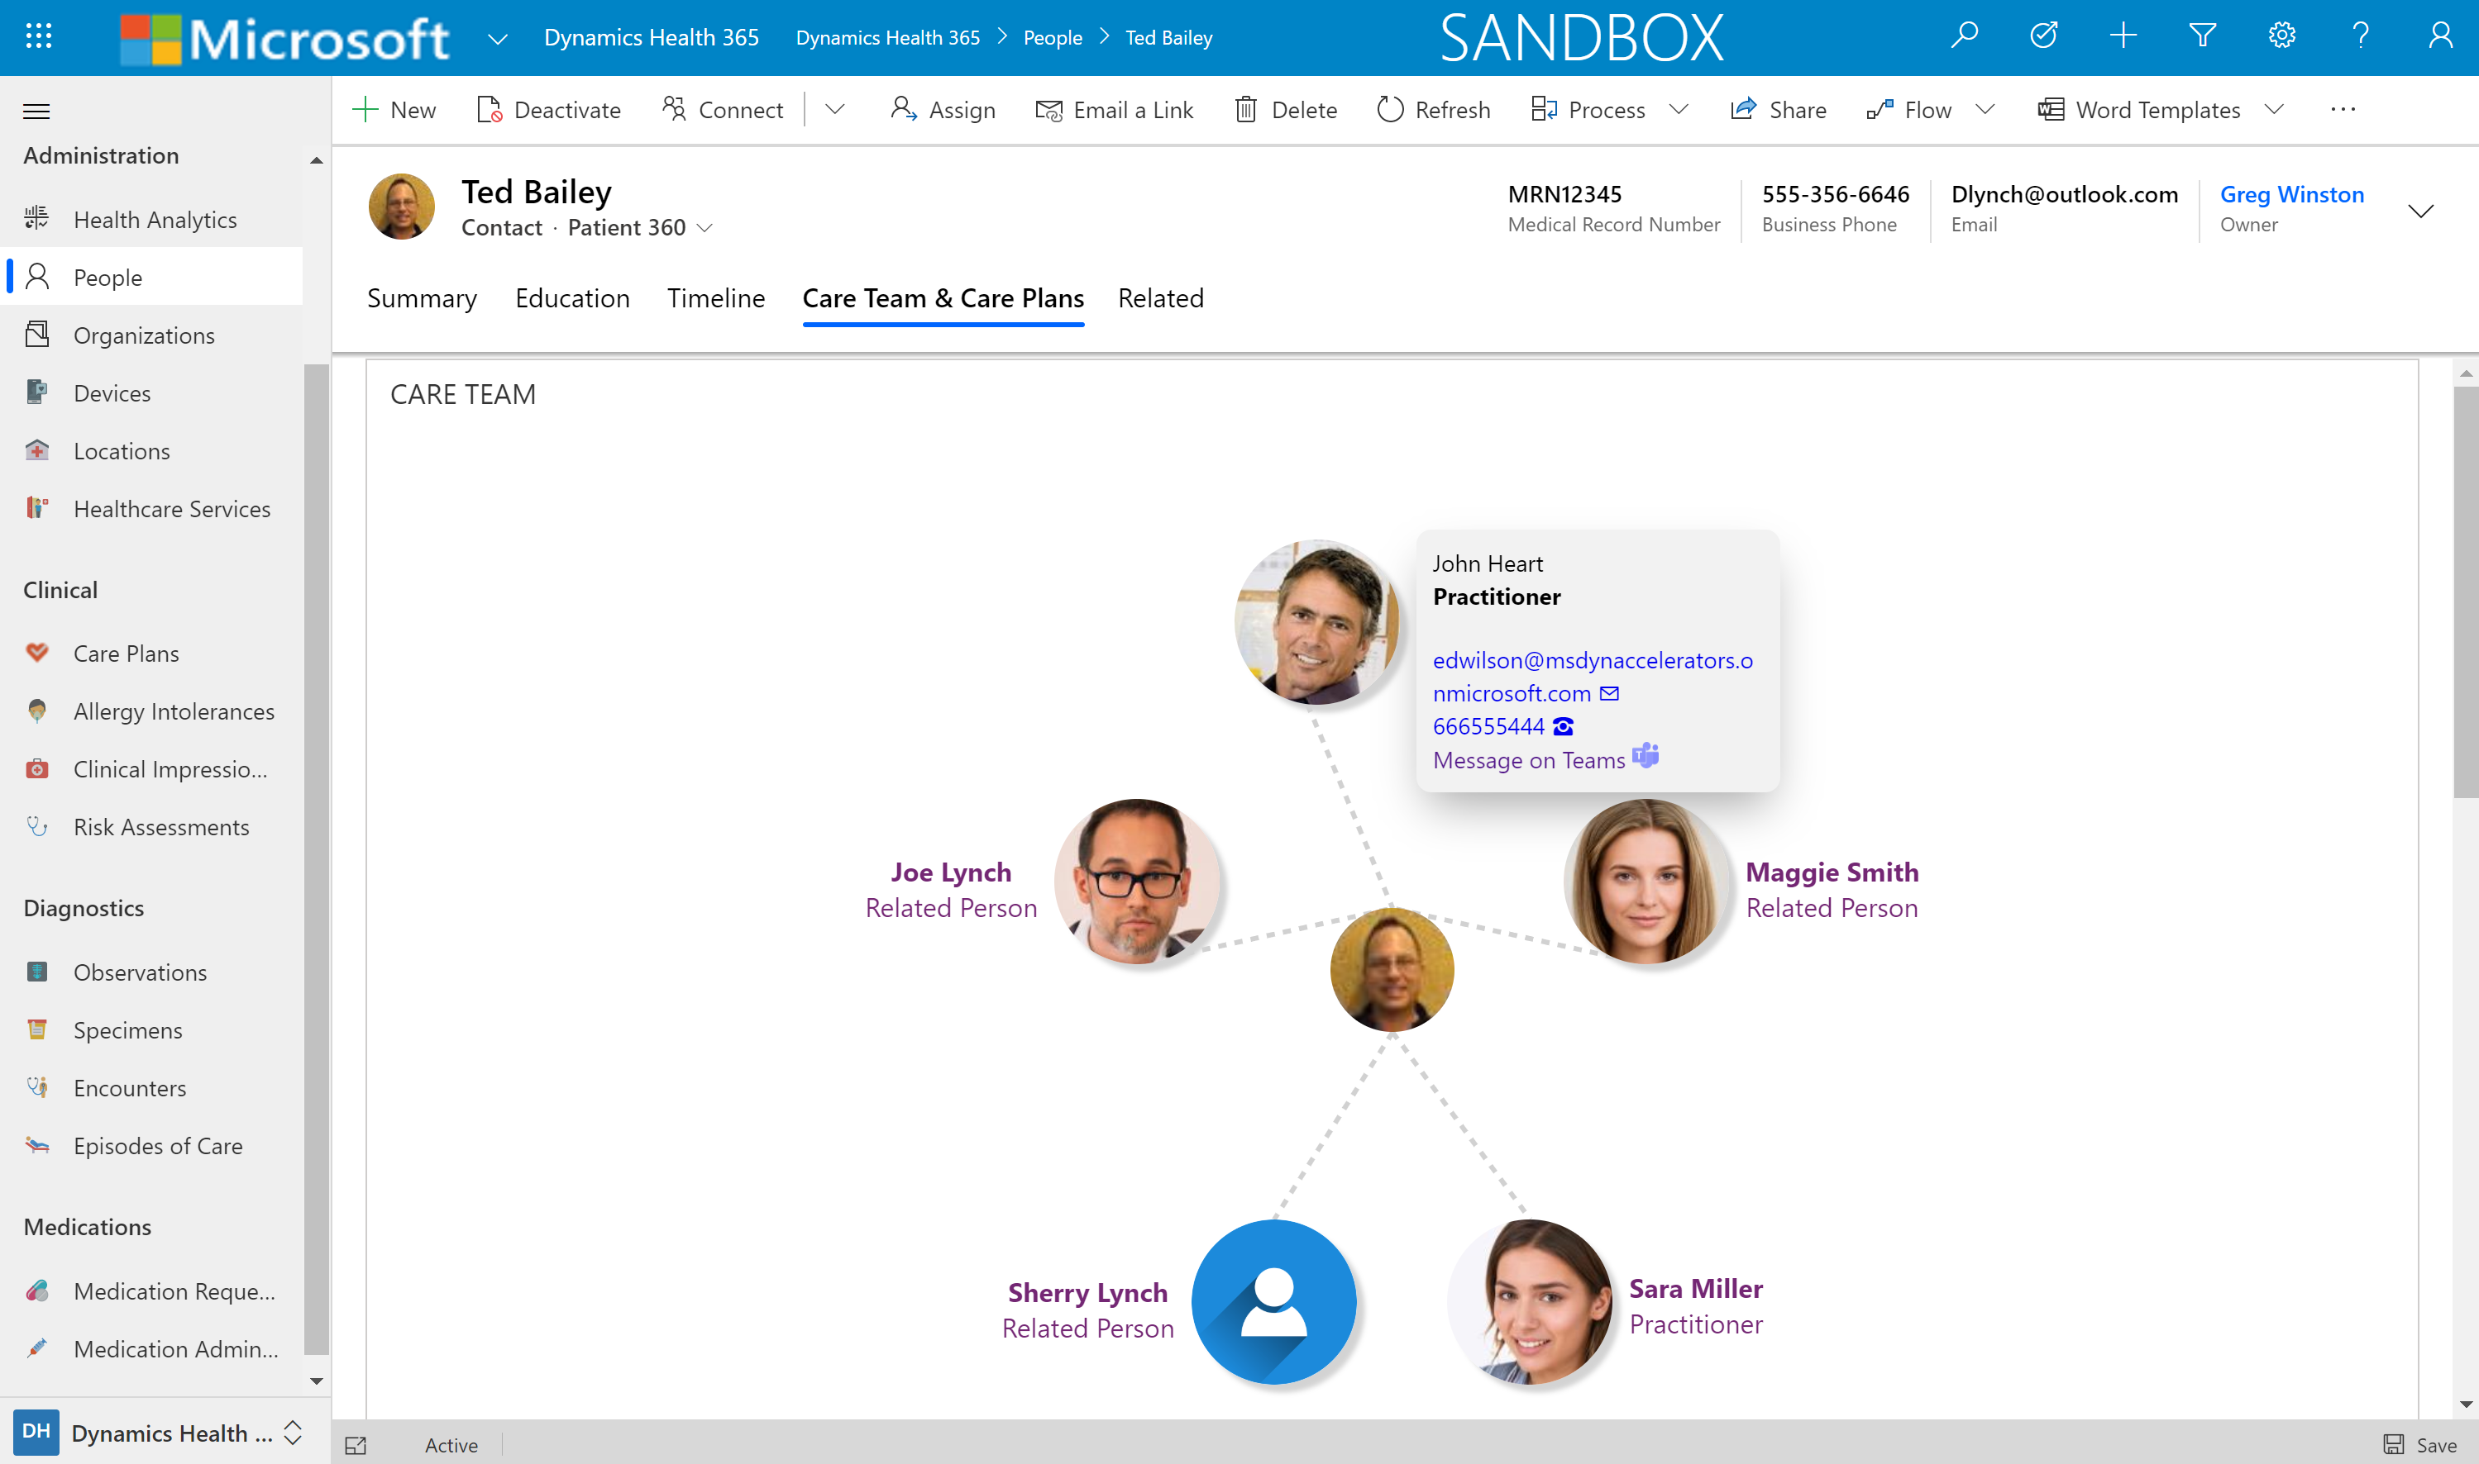

Updated Dashboards

A chief goal of the Healthcare Accelerator is to provide a baseline to create extremely robust analytics. We have created extensions that provide this however, it is important that we provide pre-built OOB dashboards that truly shows the power of the platform. First and foremost, we will need OOB dashboards for Care Coordinators to view patients and they’re open tasks. Below shows a screenshot of the OOB Care Coordinator Dashboard.

Care Coordinator Dashboard

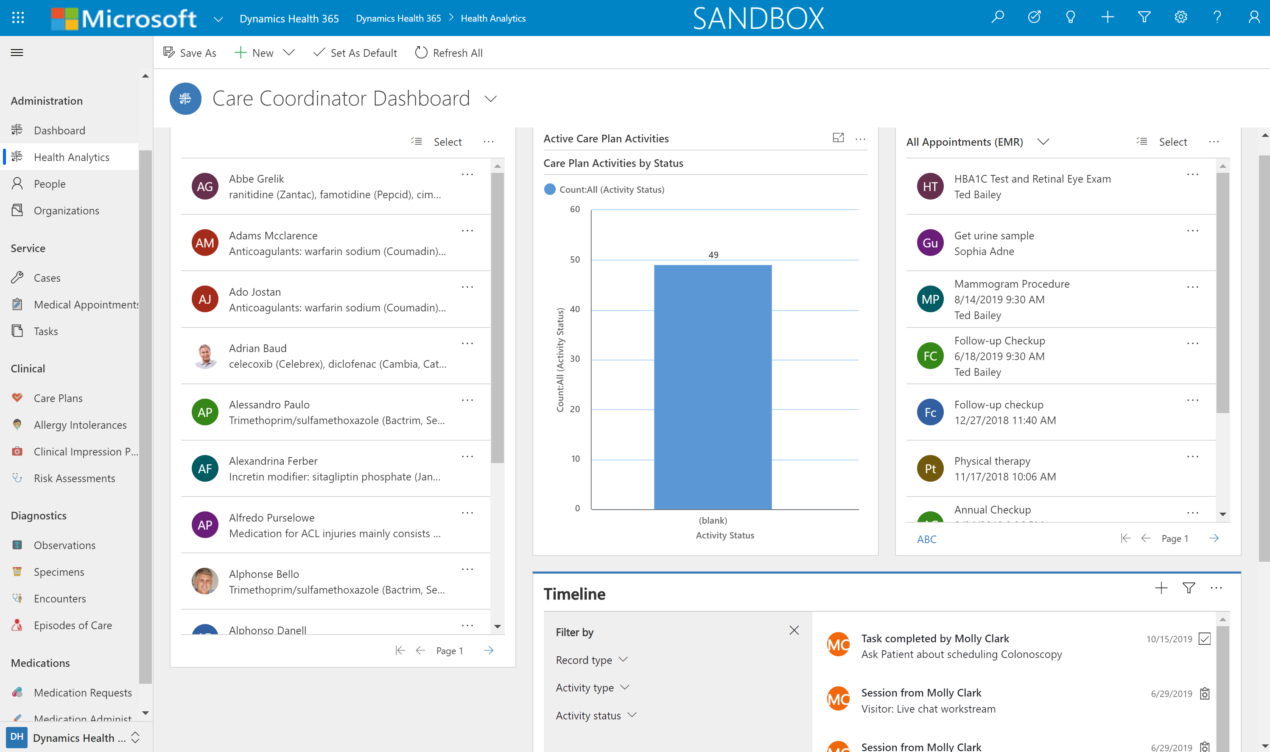

Data Model Updates

As apart of the latest release of the Healthcare Accelerator, we have stripped out all pre-requisites on Dynamics 365 apps. Now, users can directly install the Healthcare Accelerator without the need for installing the full customer engagement SKU. This enables customers/partners can take advantage of the Healthcare Accelerator without having to have a full-blown Dynamics instance, which can really streamline time to value for internal initiatives. Below is a link to a document that outlines the Data model updates:

**Link to Data Model Updates Doc**